RoundTable™ Collaboration Environment

Linux Installation Guide

Introduction
This setup guide will walk you through the process of installing the RoundTable Project Server on Linux. For the examples, we will be using RedHat Fedora 3 however, the RoundTable installation is generic and should work for any Linux system.

Java Installation
Java 5.0 is required to run the RoundTable Project Server. To obtain the latest release of Java, open a browser window and point it to http://java.sun.com. Find the “downloads” section. In that there should be a “J2SE 5.0” link as depicted in the following screen capture.
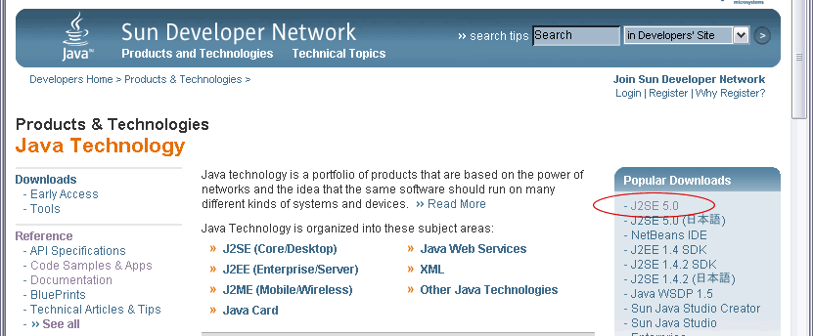

Note: This is how the Java Site appeared at the time of this writing however, it is frequently updated and might have changed drastically from how it appeared in this image.

Click on the “J2SE 5.0” link as highlighted above. Once you select the link, you will be presented with a list of Java Distributions.

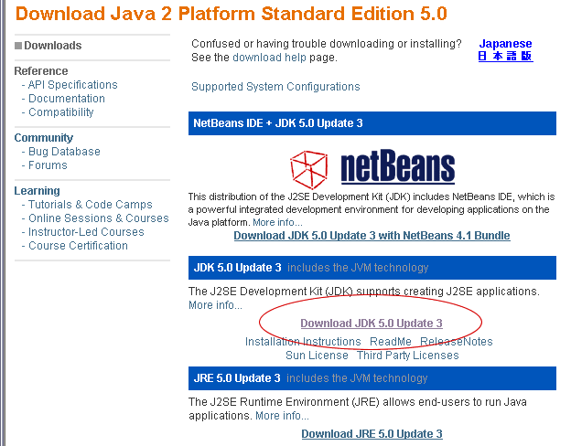

Note: It is important to select the JDK and NOT the JRE for the Linux Distribution. If you have previously installed RoundTable on Windows and downloaded the JRE that is fine however, the Linux Distribution of RoundTable uses tools that are only available in the Java JDK.

Click on the “Download JDK 5.0 Update 3” link (If there is a more recent release, download that). That will take you to a license agreement page. It is important that you read and accept that.

